**DESIGN FINAL RELEASE**

**Introduction:**

The introduction of the software requirement specification provides an overview of the entire software. The entire SRS with overview description purpose, scope, tools used and basic description.

The aim of this document is to gather, analyse and give an in-depth insight into the Secure Banking application by defining the problem statement in detail.

The detailed requirements of the Secure Banking Application is provided in this document.

**Scope:**

This project aims to create the development of secure banking application. This system consists of an application which will serve as a platform for customers to do transactions from the secure banking application.

**DATA FLOW DIAGRAM:**

 The flow of data of a system or a process is represented by DFD. It also gives insight into the inputs and outputs of each entity and the process itself. DFD does not have control flow and no loops or decision rules are present.

**LEVEL-0 DFD:**

It's a context diagram that helps map out the flow of information to better visualize processes and systems. It shows the system as a single process with its relationship to external entities.

**Level-1 DFD:**

This level-1 DFD shows a little detailed pictorial description of the secure banking.

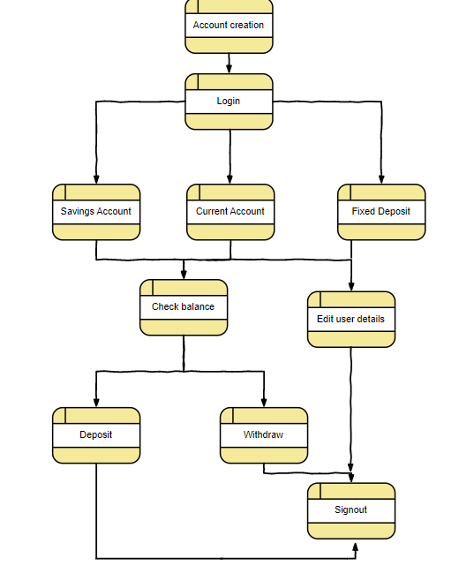

**FLOWCHART:**

* A flowchart is a picture of the separate steps of a process in sequential order. It is a generic tool that can be adapted for a wide variety of purposes, and can be used to describe various processes, such as a manufacturing process, an administrative or service process, or a project plan.

**FUNCTIONAL DIAGRAM:**

Functional diagram is an abstract representation of the product and its inner working, typically used to predict or to specify its performance.

